Assignment 5

Hypothesis

I hypothesized that “Trump” would be closely associated with “president” in the word embedding space, given his current role of President of the United States.

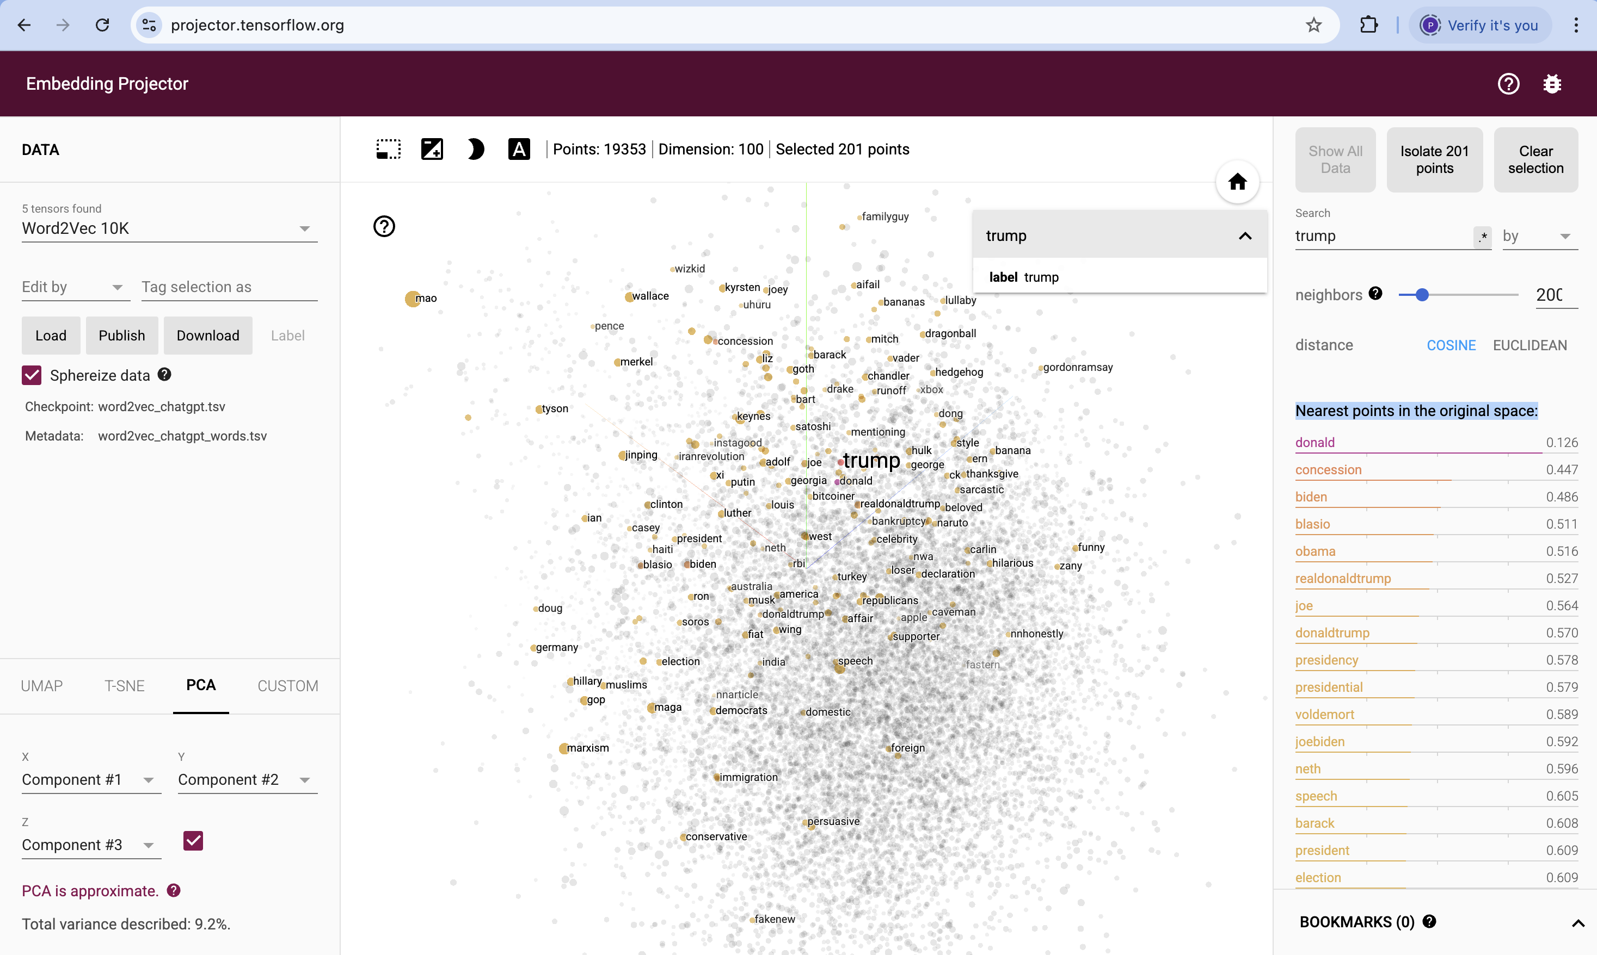

Testing the Hypothesis

To test this, I examined the nearest neighbors of “Trump” in a Word2Vec model trained on a dataset related to ChatGPT. The similarity was measured using cosine distance, which captures the contextual closeness between words.

The following are the top nearest words to “Trump” based on cosine similarity:
- donald (0.126)
- concession (0.447)
- biden (0.486)
- blasio (0.511)
- obama (0.516)
- realdonaldtrump (0.527)
- joe (0.564)
- donaldtrump (0.570)
- presidency (0.578)
- presidential (0.579)
- voldemort (0.589)
- joebiden (0.592)
- neth (0.596)
- speech (0.605)
- barack (0.608)
- president (0.609)
- election (0.609)

Analysis of Nearest Words
- Strongest associations: The closest word to “Trump” is “donald” (0.126), which is expected since “Donald Trump” is often referred to by his first name in casual discussions.
- Election-related words: Words like “concession” (0.447), “biden” (0.486), “obama” (0.516), and “election” (0.609) indicate that discussions around Trump are largely centered on elections and political opponents.
- Presidency-related terms: While “presidency” (0.578), “presidential” (0.579), and “president” (0.609) appear in the list, they are not the closest terms, meaning Trump’s association with the presidency is not as strong as expected.
- Unexpected entries: The presence of “Voldemort” (0.589) is particularly interesting, suggesting that in some contexts, Trump has been discussed in a way that might include pop culture or controversial comparisons.

Conclusion
My hypothesis that “Trump” would be closest to ‘president’” was partially supported but not strongly confirmed. Instead, the embeddings reveal that Trump’s closest associations in this dataset revolve around his name, election disputes, political opponents, and some pop culture references. This suggests that social media discourse does not solely define Trump by his presidency but rather by a mix of political and cultural discussions.

